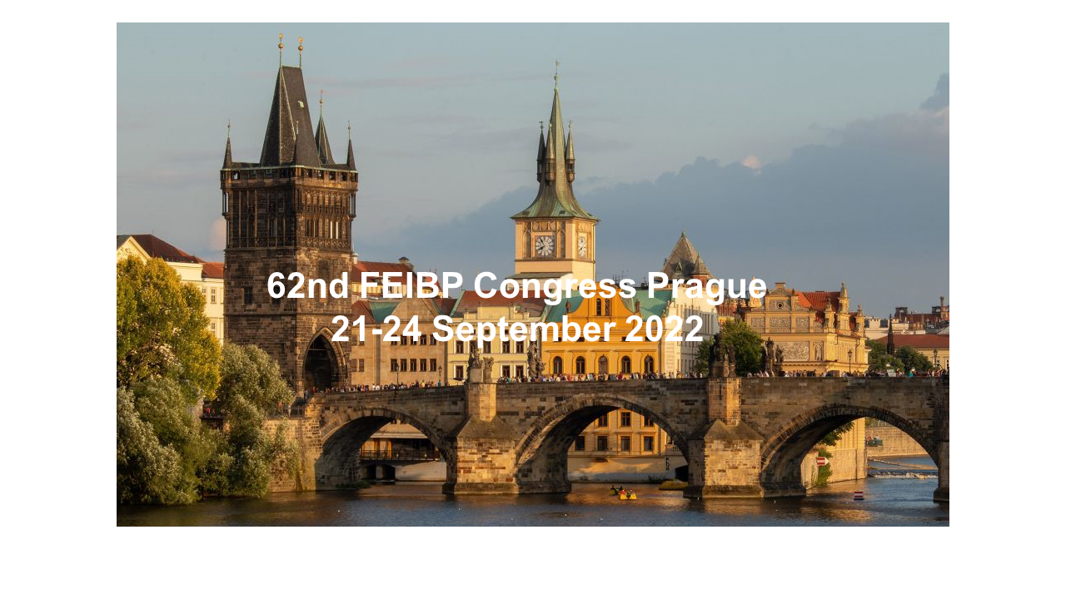
APPLICATION FORM

Sponsoring of 62nd FEIBP Congress 2022, 21-24 September, Prague, Czech Republic

The undersigned company applies for admission as sponsor to the FEIBP Congress, as follows:

Congress Three years contract
2022 2022/2023/2024

► Platinum Sponsor

► Gold Sponsor

► Silver Sponsor

Date: __________________________

Signature: Signature:

Name: __________________________

_________________________________ ______________________________
Company/Association: Andrew McIlroy, President FEIBP

